EC5070: Database Systems Lab 04

NAME: BANDARA H.G.T.D.

2022/E/048

06.06.2025

**Attach the below screenshots for following scenarios.**

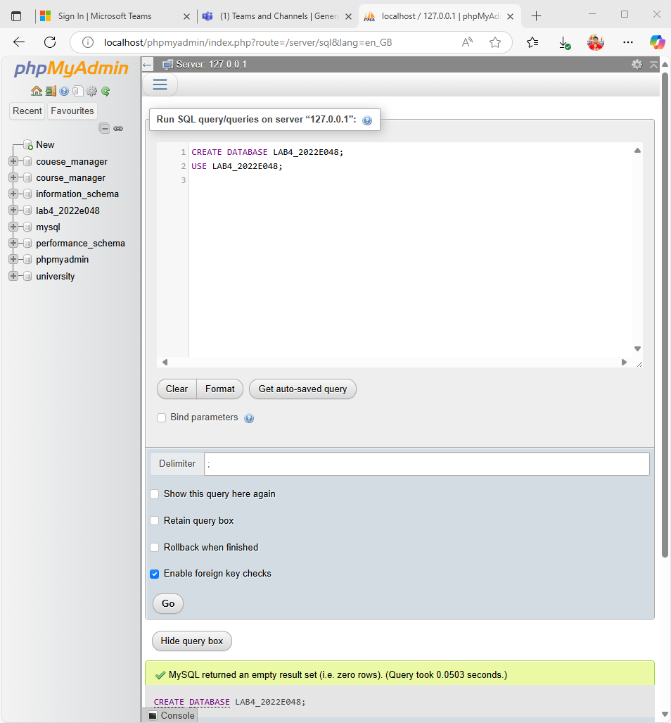Q1. Database with your registration number and lab number.

FIGURE 01:QUERY FOR CREATE DATABASE

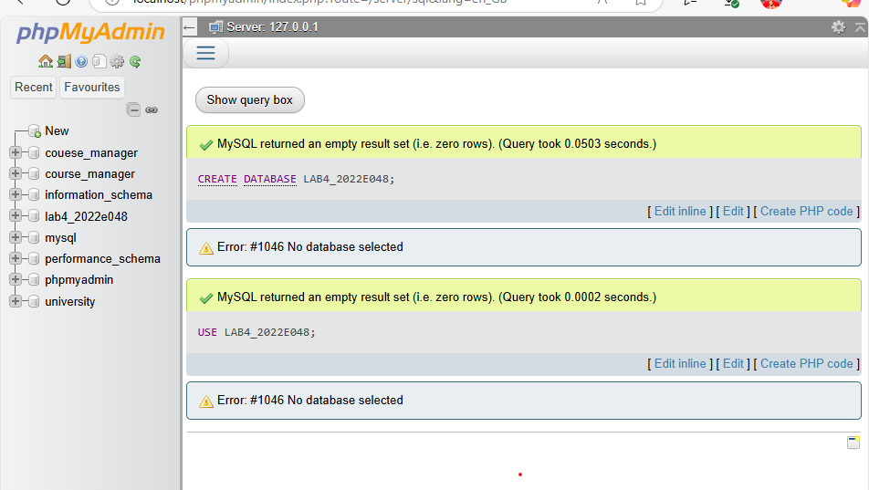

FIGURE 02 :DATABASE CREATED SUCCESSFULLY

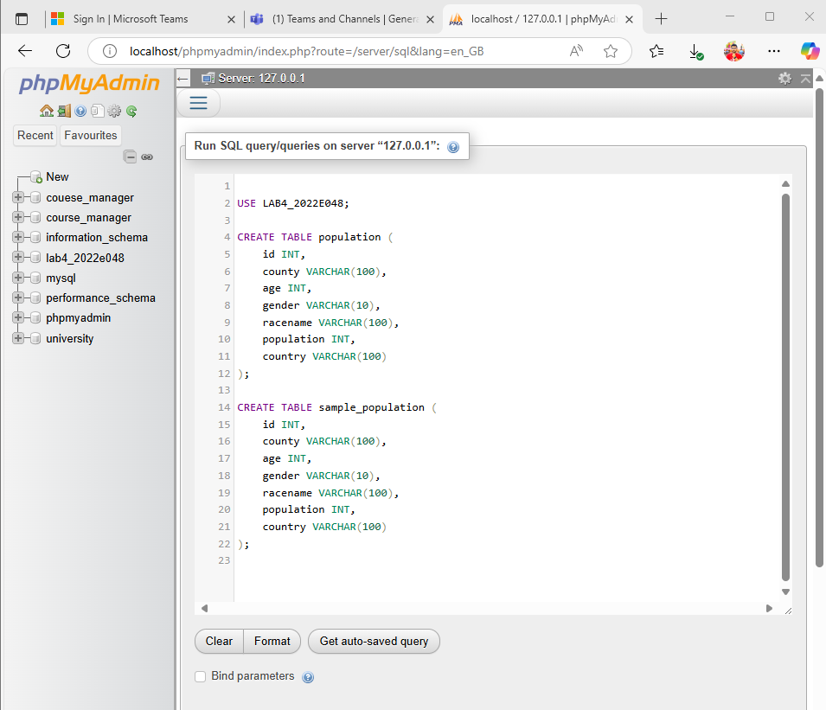Q2. Tables with the name sample population and population.

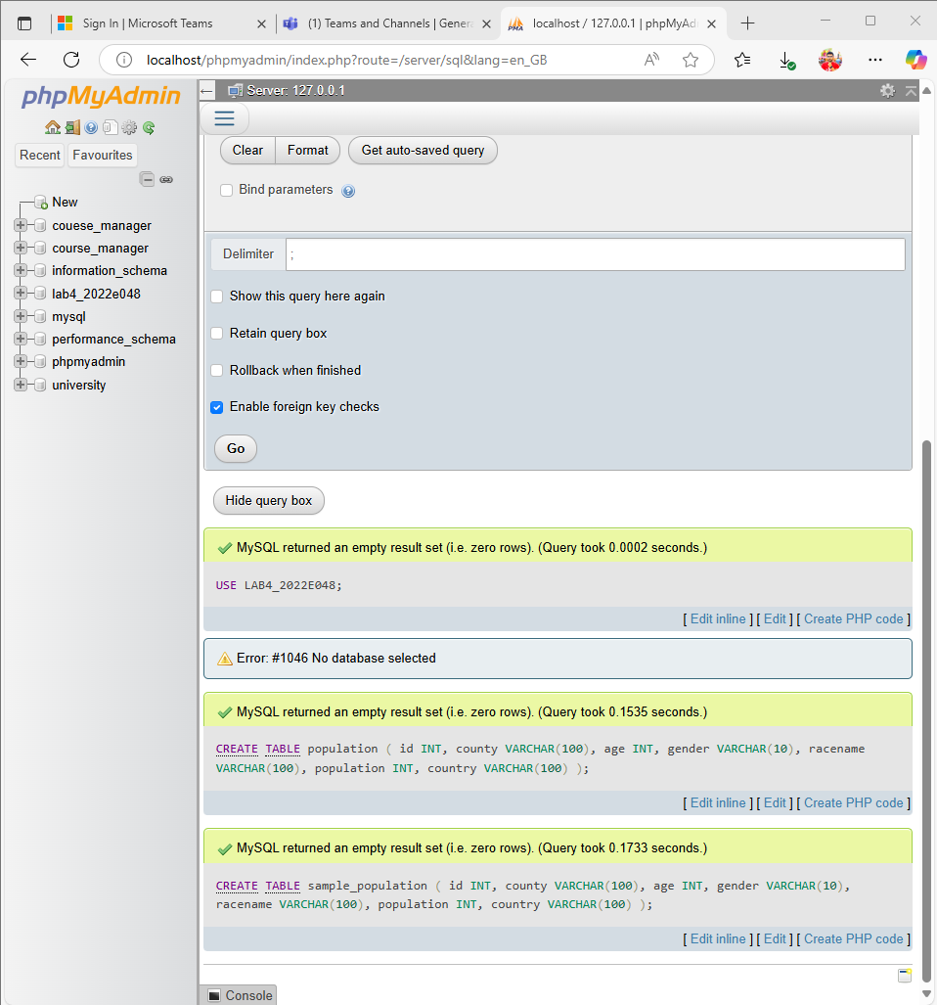FIGURE 03: QUERY FOR CREATING TABLES

FIGURE 04: CREATE TABLES SUCCESSFULLY

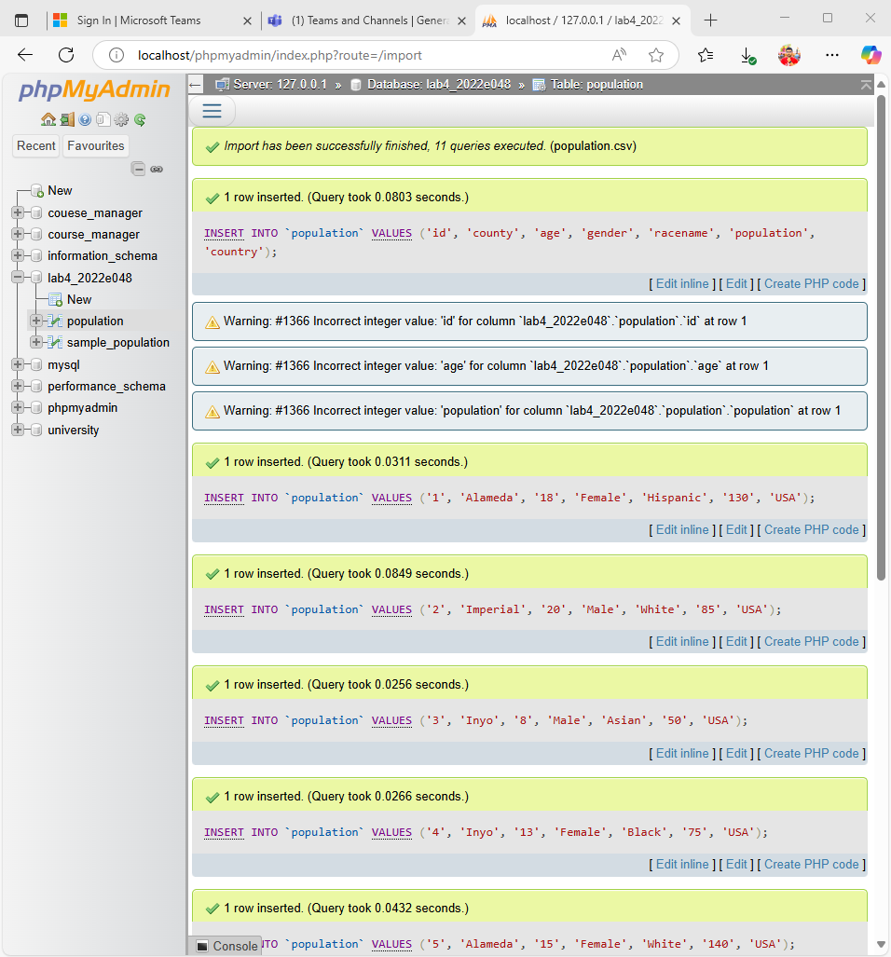Q3. Importing .csv files using import data wizard.

FIGURE 05: IMPORT population.csv FILE

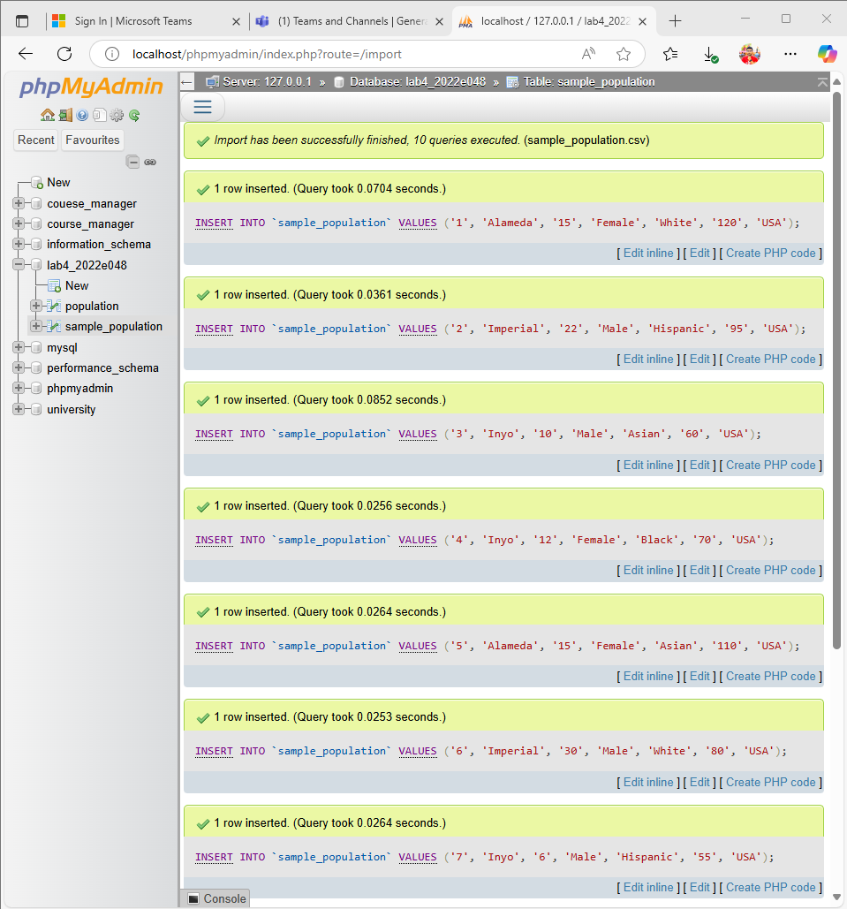

FIGURE 06: IMPORT sample_population.csv FILE

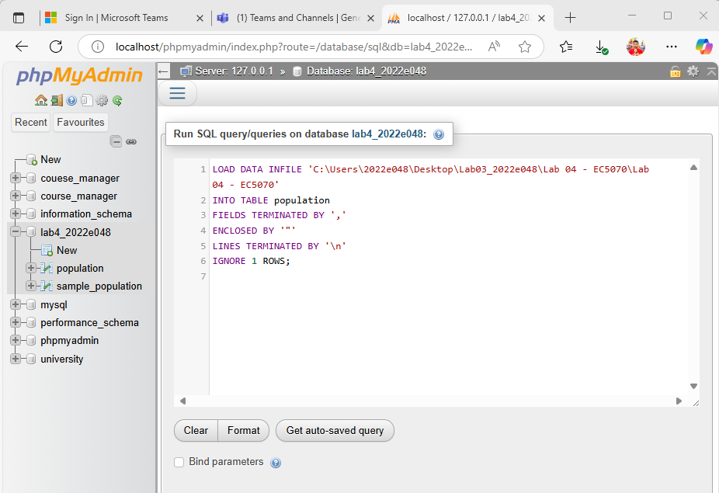Q4. Importing .csv files using queries

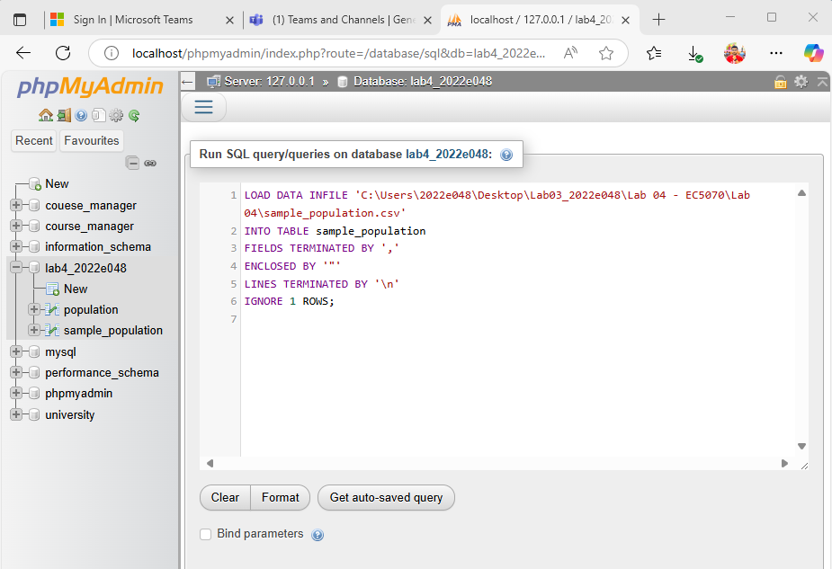FIGURE 07: QUERY FOR IMPORT population.csv

FIGURE 08: QUERY FOR IMPORT sample_population.csv

Q5. Explanation of your observation for question 3,4.

Observation for Q3 & Q4:

The import using the wizard was easier and good for small files. However, the query-based import (LOAD DATA INFILE) was faster for larger files. It required correct file path and permissions but gave better control and performance for repeated use.

**Observations on Data Import (Wizard vs. Queries):**

* **Ease of Use for Beginners:** The **Data Import Wizard** (Question 3) is generally more user-friendly for those new to databases or SQL. Its graphical interface and step-by-step guidance reduce the barrier to entry, making it easy to perform imports without memorizing SQL syntax or command structures. You visually select files, tables, and map columns.
* **Control and Automation:** Importing data using **SQL queries (LOAD DATA INFILE)** (Question 4) offers much greater control and is essential for automation. With LOAD DATA INFILE, we have precise command over delimiters, line endings, error handling (e.g., REPLACE or IGNORE), and column mapping. This method is highly scriptable, meaning we can include it in shell scripts, Python scripts, or other batch processes to automate regular data imports without manual intervention.
* **Troubleshooting:** Errors in the wizard are often presented in a more digestible format, but troubleshooting can be a "black box" if we don't understand the underlying SQL. With LOAD DATA INFILE, errors might be less descriptive but are often directly related to the SQL syntax or file issues, which is more transparent for a user familiar with SQL.
* **Performance (for large files):** For very large CSV files, LOAD DATA INFILE is typically much faster and more resource-efficient than inserting row by row (which some wizards might do internally, though many now use optimized methods). It's designed for bulk loading.

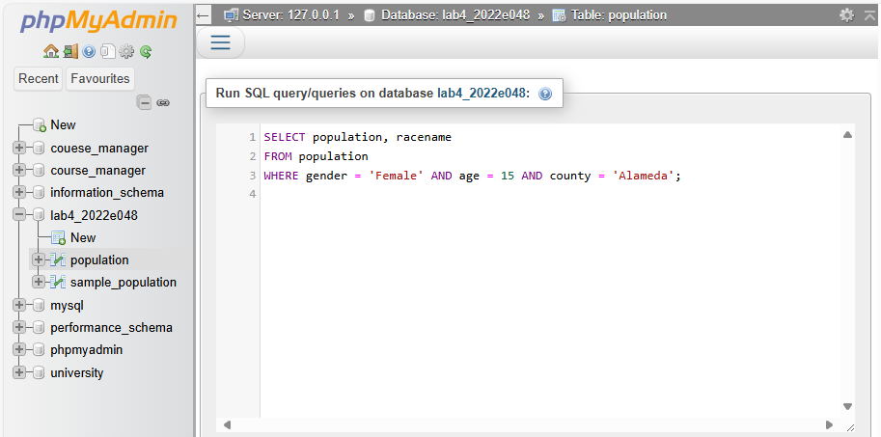Q6. Attach the screen shots for each queries given in question 6.

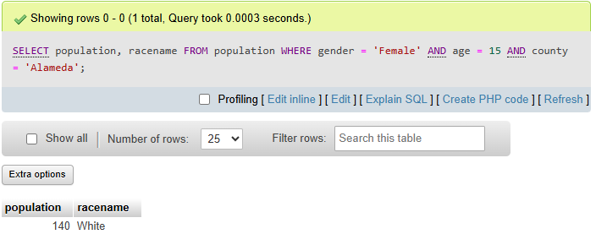FIGURE 09: QUERY FOR SUBPART 1 IN PART 06

FIGURE 10: OUTPUT FOR SUBPART 1 IN PART 06

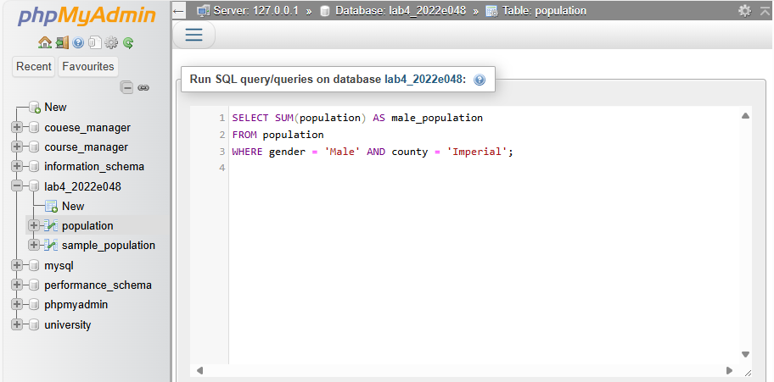

FIGURE 11: QUERY FOR SUBPART 2 IN PART 06

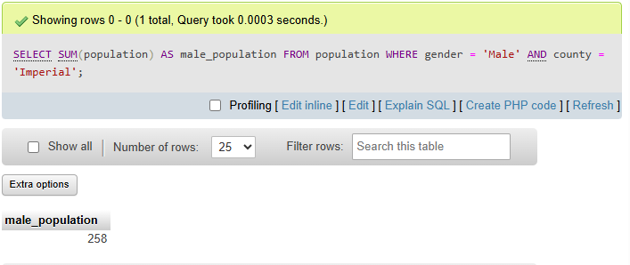

FIGURE 12: OUTPUT FOR SUBPART 2 IN PART 06

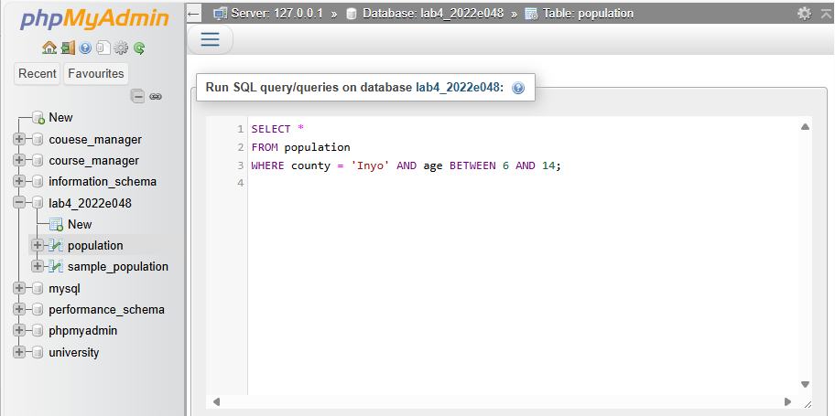

FIGURE 13: QUERY FOR SUBPART 3 IN PART 06

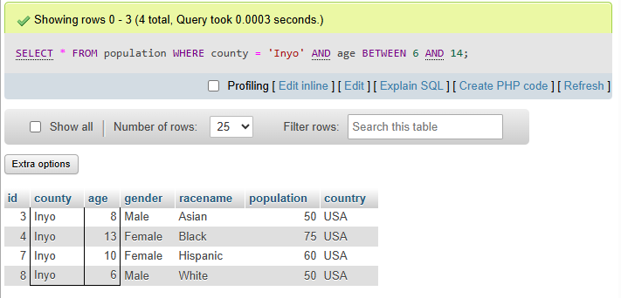

FIGURE 14: OUTPUT FOR SUBPART 3 IN PART 06

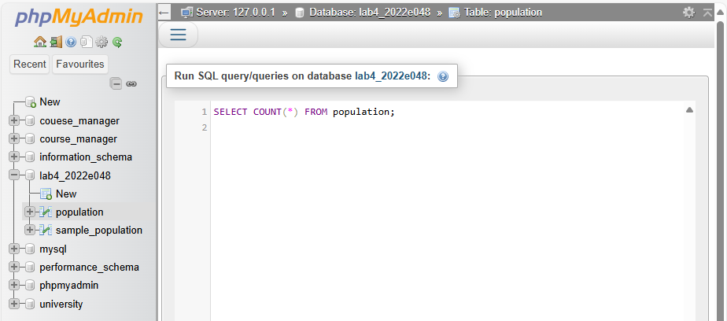

FIGURE 15: QUERY FOR SUBPART 4 IN PART 06

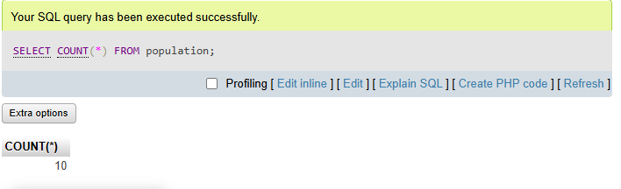

FIGURE 16: OUTPUT FOR SUBPART 4 IN PART 06

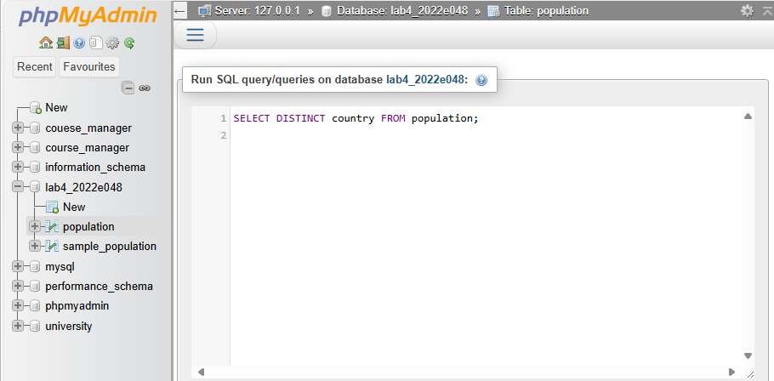

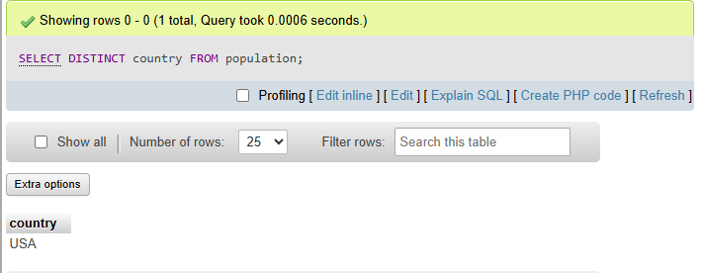FIGURE 17: QUERY FOR SUBPART 5 IN PART 06

FIGURE 18: OUTPUT FOR SUBPART 5 IN PART 06

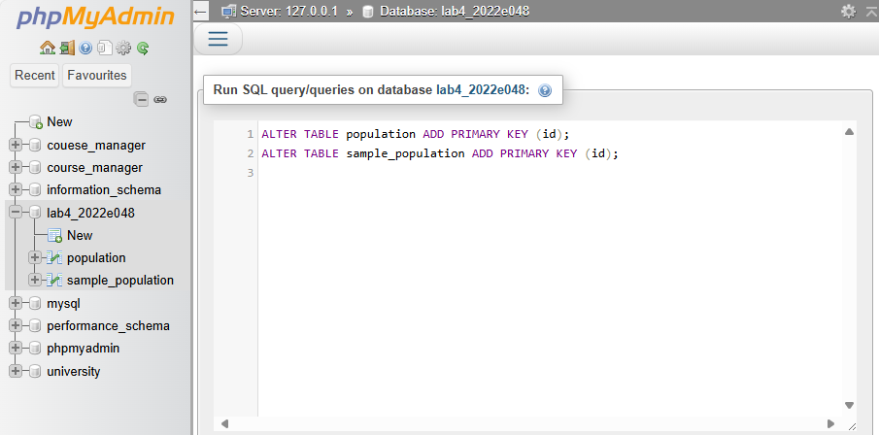Q7. Screenshot for create the primary key for two tables and the listed queries in question 4.

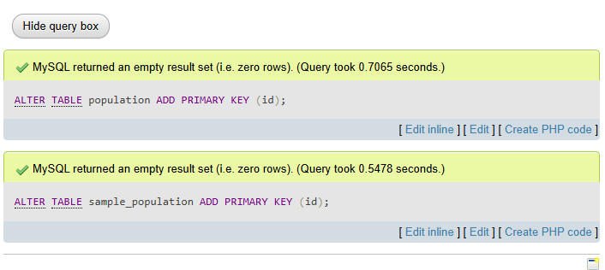FIGURE 19: QUERY FOR PART 07

FIGURE 20: OUTPUT FOR PART 07

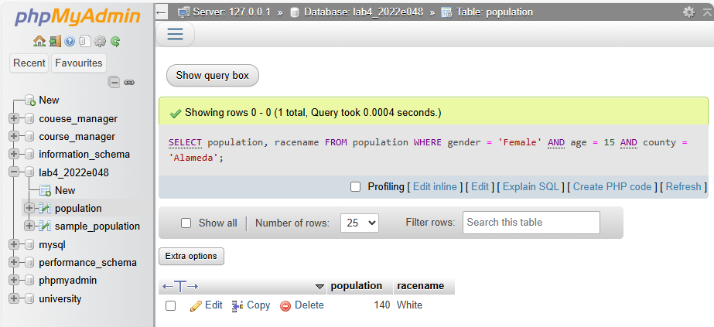

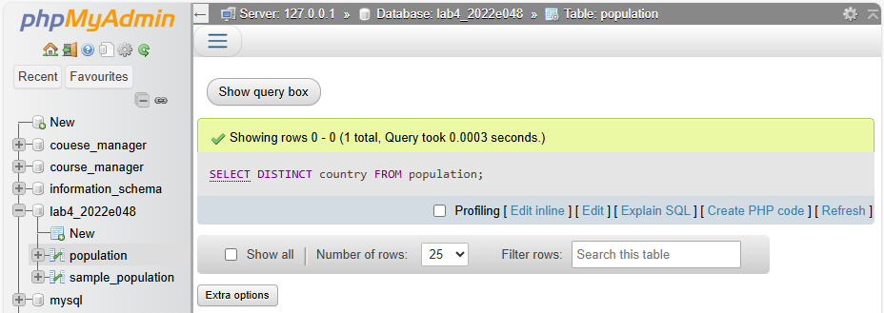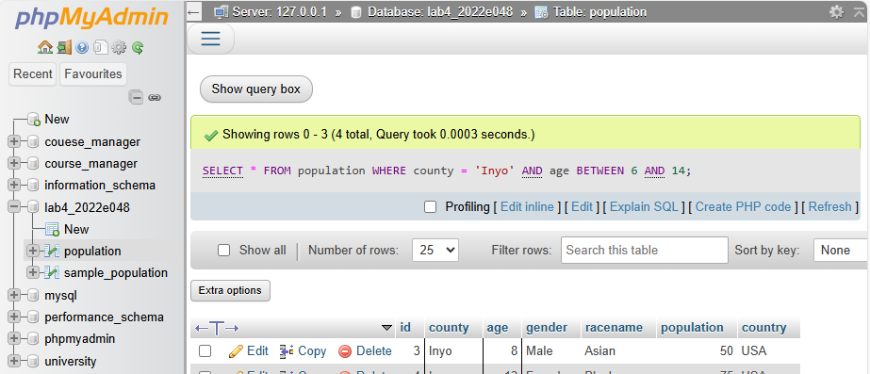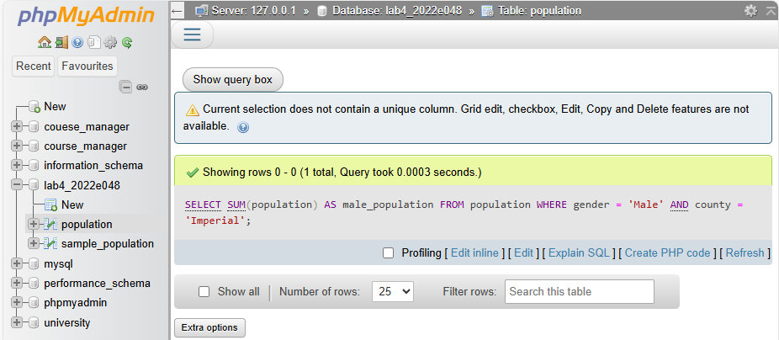

FIGURE 21: TIME DURATIONS FOR PART 06(AFTER PART 07)

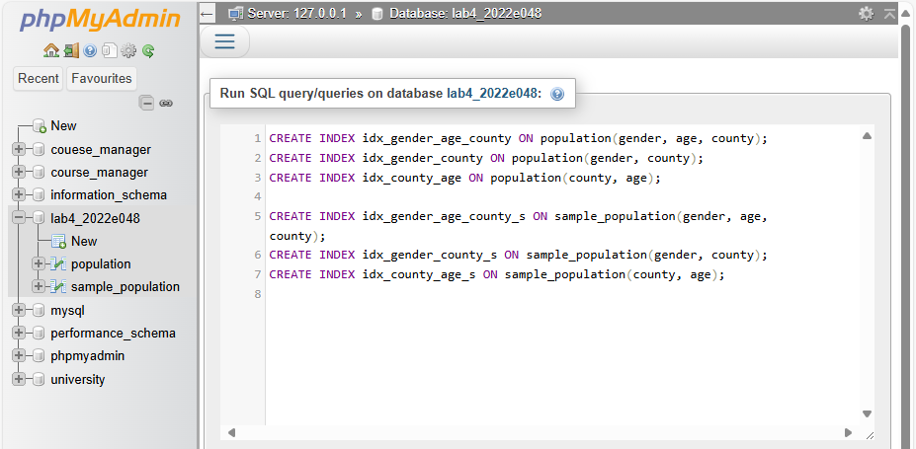Q8. Screenshot for create the secondary index for these two tables and do the queries again (in question 4) and the time duration

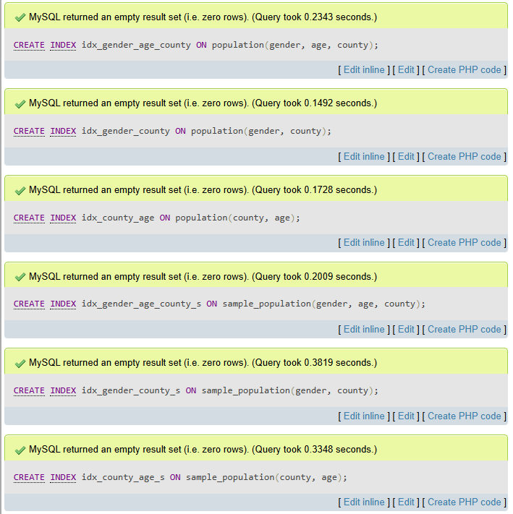FIGURE 22: QUERY PART 08

FIGURE 23: OUTPUT FOR PART 08

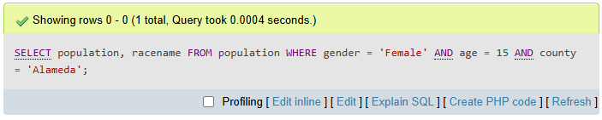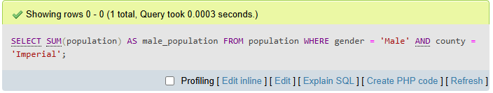

FIGURE 24: TIME DURATIONS FOR PART 06(AFTER PART 08)

Q9. Explanation for question 4,5,6.

**Final Observations (Q4, Q5, Q6):**  
Without indexing, the queries took longer, especially when filtering on multiple columns. After adding a **primary key**, we noticed a slight performance improvement on queries using id. However, the **secondary indexes** on gender, county, and age drastically reduced execution time, especially for complex WHERE clauses. This shows the effectiveness of indexes for large datasets in real-time querying.